**Name: ……… ….. ID: ……………………. Sec: ……**

1. What is the oxidation number for each of the following elements? (1* 3 = 3 points)

(e.n.’s: C = 2.5, O = 3.5, H = 2.1)

a. Co in Co (NO3)3 ________

b. O in HCHO ________

c. I in IO4- ________

2. Draw energy diagrams of exothermic and endothermic reaction with low activation energy. (4 points)

3. What kind of reaction is shown below (between hydrogen peroxide and magnesium sulfite) (1+2+2 = 5 points)

1. H2O2(aq) + MgSO3(aq) MgSO4(aq) + H2O

Precipitation gas formation acid-base neutralization redox reaction

b. Write the total ionic equation for the reaction shown in Question a.

c. Now convert the total ionic equation in Question b into its net ionic equation.

4. Write the formula for the precipitate that forms when a solution of Cu(NO3)2 is added to a solution of NaOH. (2 points)

5. Explain which of the compounds represent the MOST OXIDIZED and MOST REDUCED class? (3+3 = 6 points)

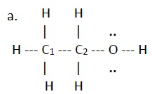 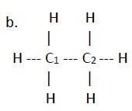

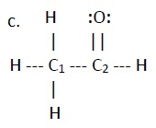 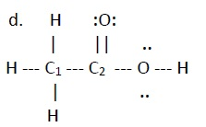

Answer with the number of the compound:

Most oxidized:

Most reduced:

1. (5 points) Examine the figure and below answer the following questions



1. What type of reaction is this ......................
2. What is indicated by the letter A .....................
3. What is indicated by the letter B .....................
4. What is indicated by the letter C .....................
5. What is indicated by the letter D .....................